17 November 2021 Mr.ephraim

Just Coders IT Solutions



PROJECT REQUIREMENTS ANALYSIS DOCUMENT

**Inside Cover Page**

* **Number of the team**
* DISD313 Group 4, with 3 members
* **Name of the team**
* Just Coders
* **Name and student number of team leader**
* Vusimuzi Mphela 17608576
* **Names and student numbers of team members**
* Given Mnguni 18011644
* Ntandoyenkosi Ndaba 16011865
* **Name and logo of the system**
* The Ben Luc System



Table of Contents

1. **Problem Domain3**
2. **Solution Domain4**
   1. Functional requirements of website4
   2. Functional requirements of application4
   3. UML Use Cases5
3. **Logical System Model6**
4. **Class Diagrams7**
5. **Appendix B9**

# Problem Domain

The ben Luc clothing store has only 1 branch in Pretoria Central, the organization has no website were regular customers or potential customers can review their brand items and make purchases.

The regular customers or potential customers are unable to make online purchases of their favorite Ben Luc clothing items because the organization has no website where customers can interact with the services the organization offers, and the website would greatly be convenient for customers who are far away from making an in-store purchase.

# Solution Domain

Functional Requirements of the Ben Luc system

* Ben Luc System website
* Enable the customer to browse through the wide variety of clothing items that the store offers.
* Enable customers to give feedback about the service they received from the organization.
* The website must have a login and registration page which will allow customers to create accounts, the accounts will help customers make online orders of their favorite clothing items.
* The website of the must be easy to use, navigate and make an online purchase.
* Ben Luc System Android Application
* The android application is expected to have a login and registration which will authenticate customers before they can interact with the application.
* The android application is expected to be user friendly, easy to use and navigate.
* The android application is expected to allow the customer to add one or more products to the shopping cart.
* The android application is expected to have a section which will track orders that are made by customers through the order management section.
* The android application is expected to allow the customer to choose between delivery or collect as a payment option.

# 2.3 UML Use Cases

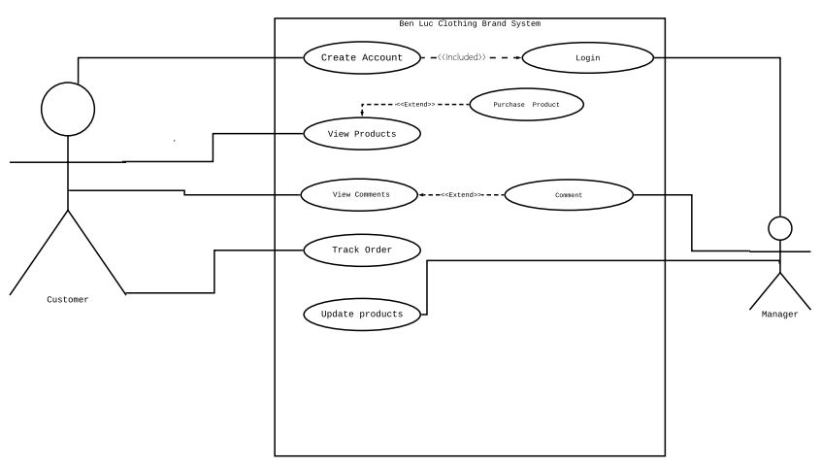

# Logical System Model

|  |  |  |  |  |
| --- | --- | --- | --- | --- |
| GUI   |  |  | | --- | --- | | Input | Output | | System process(method) | Entity relationship (Table) |
| |  |  | | --- | --- | | Enter customer details |  | | Register a new customer | Customers table |
| |  |  | | --- | --- | | Checkout one or more products added to cart |  | | Create an order for the customer | Orders table |
| |  |  | | --- | --- | | Update prices and change product name |  | | Create and update products | Products table |
| |  |  | | --- | --- | | No input | No output | | Calculate sale figures | Order-product table |
| |  |  | | --- | --- | | No input | Sale report/receipt print | | Print sales Report/receipt for the customer | Order-product table |

# Class Diagrams

|  |  |  |
| --- | --- | --- |
| Name of entity (UML Class) | Properties of entity (UML Class) | Related to: |
| Customer | cid (int – 10 characters)  fname (string – 50 characters)  lname (string – 50 characters)  email (string – 50 characters)  password (string – 200 characters) | Account |
| Orders | Oid (int – 10 characters)  cid (int – 10 characters)  Datecreation (date)  Delivery_date (date) | Sale |
| Products | Pid (int – 10 characters)  Pname (string – 50 characters)  Price (double – 10,2 characters)  Image (string – 50 characters)  Qnty (int – 10 characters) | Product |
| Order-product | Oid (int – 10 characters)  Pid (int – 10 characters)  Price (double – 10,2 characters)  Qnty (int – 10 characters) | Order |
| Customer-comment | Comment_id (int – 10 characters)  cid (int – 10 characters)  comment (string – 200 characters) | Feedback |
| Admin | Admin_email (string – 50 characters)  Password (string – 200 characters) | Management |

# Appendix B

The Ben Luc system has been developed using different tools, the Ben Luc system’s website has been developed using PHP programming language, html, CSS, notepad++ and a bit of java-script. The Ben Luc system’s android application has been developed using android studio integrated development environment (IDE), java programming language and Json files were used to retrieve the product images from firebase database.

The Ben Luc system has been developed using a 3-tier model, the system uses Wamp/Xampp server to communicate with the system database and the database that was used for the CRUD (create, update, delete) operations is MySQL.